Packet Tracer - FTP Servers

1. Topology

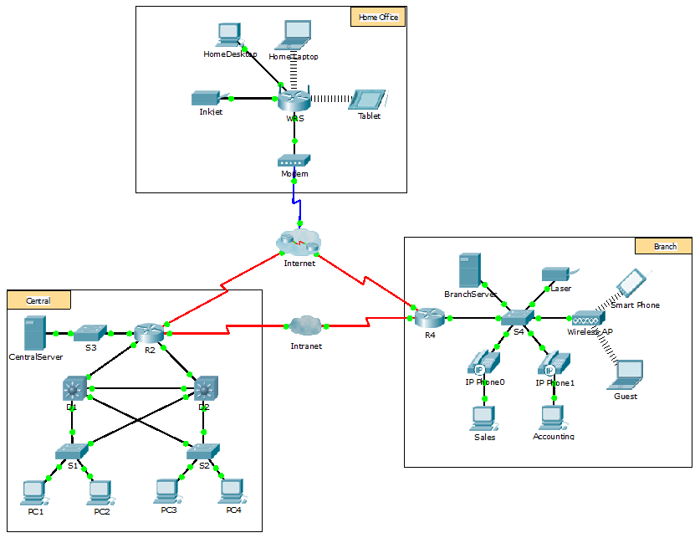

Objectives

Part 1: Configure FTP Services on Servers

Part 2: Upload a File to the FTP Server

Part 3: Download a File from the FTP Server

Background

In this activity, you will configure FTP services. You will then use the FTP services to transfer files between clients and the server.

**Note**: Packet Tracer only simulates the process for configuring these services. FTP server and client software packages each have their own unique installation and configuration instructions. The first time you attempt to connect to a web address, Packet Tracer takes several seconds to simulate the DNS name resolution process.

1. Configure FTP Services on Servers
   1. Configure the FTP service on CentralServer.
      1. Click **CentralServer** > **Services** tab > **FTP**.
      2. Click **On** to enable FTP service.
      3. In **User Setup**, create the following user accounts. Click **Add** to add the account:

|  |  |  |
| --- | --- | --- |
| Username | Password | Permissions |
| anonymous | anonymous | limited to **Read** and **List** |
| administrator | cisco | full permission |

* + 1. Click the default **cisco** user account and click **Remove** to delete it. Close the CentralServer configuration window.
  1. Configure the FTP service on BranchServer.

Repeat Step 1 on **BranchServer**.

1. Upload a File to the FTP Server
   1. Transfer the README.txt file from the home laptop to CentralServer.

As network administrator, you must place a notice on the FTP servers. The document has been created on the home laptop and must be uploaded to the FTP servers.

* + 1. Click **Home Laptop** and click the **Desktop** tab > **Text Editor**.
    2. Open the **README.txt** file and review it. Close the **Text Editor** when done.

**Note**: Do not change the file because this affects scoring.

* + 1. In the **Desktop** tab, open the Command Prompt window and perform the following steps:
       1. Type **ftp centralserver.pt.pka**. Wait several seconds while the client connects.

**Note**: Because Packet Tracer is a simulation, it can take up to 30 seconds for FTP to connect the first time.

* + - 1. The server prompts for a username and password. Use the credentials for the **administrator** account.
      2. The prompt changes to ftp>. List the contents of the directory by typing **dir**. The file directory on **CentralServer** displays.
      3. Transfer the README.txt file: at the ftp> prompt, type **put README.txt**. The README.txt file is transferred from the home laptop to **CentralServer**.
      4. Verify the transfer of the file by typing **dir**. The README.txt file is now listed in the file directory.
      5. Close the FTP client by typing **quit**. The prompt will return to PC>.
  1. Transfer the README.txt file from the home laptop to BranchServer.
     1. Repeat Step 1c to transfer the README.txt file to **branchserver.pt.pka**.
     2. Close the Command Prompt and Home Laptop windows, respectively.

1. Download a File from the FTP Server
   1. Transfer README.txt from CentralServer to PC2.
      1. Click **PC2** and click the **Desktop** tab > **Command Prompt**.
         1. Type **ftp centralserver.pt.pka**.
         2. The server prompts for a username and password. Use the credentials for the **anonymous** account.
         3. The prompt changes to ftp>. List the contents of the directory by typing **dir**. The README.txt file is listed at the top of the directory list.
         4. Download the README.txt file: at the ftp> prompt, type **get README.txt**. The README.txt file is transferred to **PC2**.
         5. Verify that the **anonymous** account does not have the permission to write files to **CentralServer** by typing **put sampleFile.txt**. The following error message displays:

Writing file sampleFile.txt to centralserver.pt.pka:

File transfer in progress...

%Error ftp://centralserver.pt.pka/sampleFile.txt (No such file or directory Or Permission denied)

550-Requested action not taken. permission denied).

* + - 1. Close the FTP client by typing **quit**. The prompt returns to the PC> prompt.
      2. Verify the transfer of the file to PC2 by typing **dir**. README.txt is listed in the directory.
      3. Close the command line window.
    1. In the **Desktop** tab, open the **Text Editor** and then the **README.txt** file to verify the integrity of the file.
    2. Close the **Text Editor** and then the PC2 configuration window.
  1. Transfer the README.txt file from BranchServer to the Smart Phone.

Repeat Step 1 for **Smart Phone**, except download the README.txt file from **branchserver.pt.pka**.